**Assignment – 03**

|  |  |
| --- | --- |
| Assignment Date | 06 October 2022 |
| Team ID | PNT2022TMID02807 |
| Project Name | Smart Fashion Recommender Application |
| Batch no. | B4-4M6E |
| Maximum Marks | 2 Marks |

**Question 1 :**

Create a Bucket in IBM Object Storage.

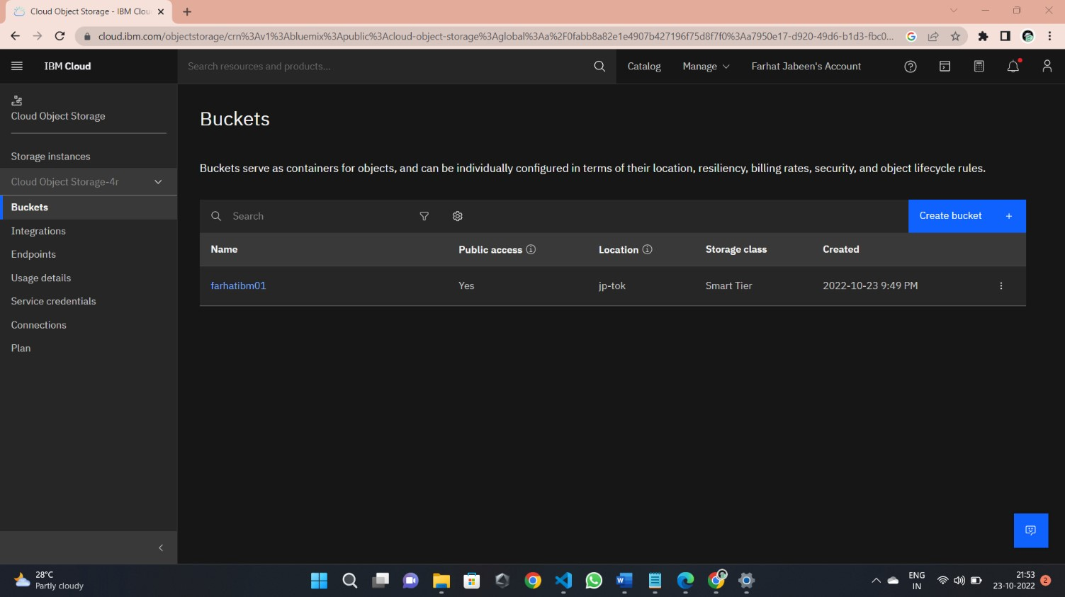

**Question 2 :**

Upload 5 images to IBM object storage and make it public. Write html code to displaying all the 5 images.

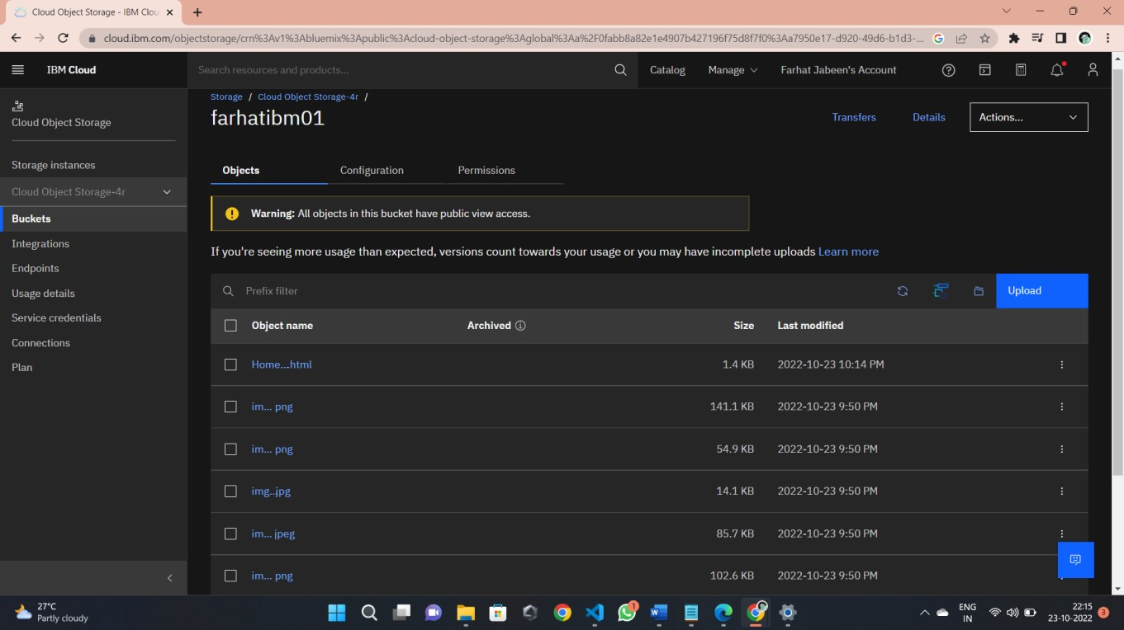

**Question 3 :**

Upload a CSS page to the object storage and use the same page in your HTML code.

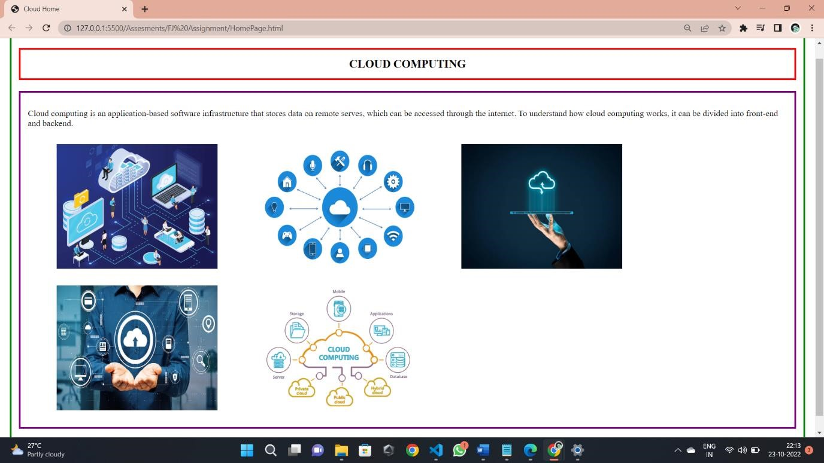

**Question 4 :**

Design a chatbot using IBM Watson assistant for hospital. Ex: User comes with query to know the branches for that hospital in your city. Submit the web URL of that chat bot as a assignment.

**https://web-chat.global.assistant.watson.appdomain.cloud/preview.html?backgroundImageURL=https%3A%2F%2Fjptok.assistant.watson.cloud.ibm.com%2Fpublic%2Fimages%2Fupx-c1aaf68f-d205-4bd9-bf25-**

**f5fa86190b09%3A%3A1071984c-b9da-4227-bf06-9f6bd049d9ca&integrationID=b07b239f-88f7-42f7-94be8794ee5939b2&region=jp-tok&serviceInstanceID=c1aaf68f-d205-4bd9-bf25-f5fa86190b09**

**Question 5 :**

Create Watson assistant service with 10 steps and use 3 conditions in it. Load that script in HTML page.

